Joyland
Marketing Pack for venues, part of BFI FAN’s support for new releases “Joyland is a profoundly moving film that might just make a difference.”
Ryan Leston, Slashfilm
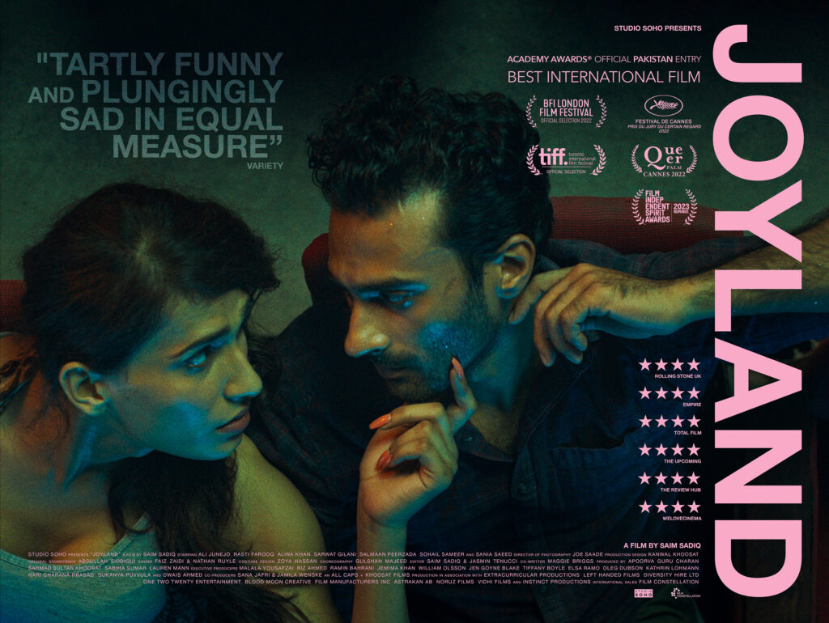
Specification details:
Dir. Saim Sadiq | Cert. TBC | 126 mins | Pakistan | 2022
Distributor: Studio Soho Distribution
Available: 24 February 2023
Booking: dave@jadefilms.co.uk
- HoH captioned versions of the film are available to book.

Deliveries Contact: karen@studiosohodistribution.com & jordan@studiosohodistribution.com

Logline:
The Ranas - a happily patriarchal joint family - yearn for the birth of a baby boy to continue the family line. However when their youngest son secretly joins an erotic dance theatre and falls for an ambitious trans starlet, their impossible love story slowly illuminates the entire Rana family's desire for sexual rebellion.

Short Synopsis:
Set in bustling Lahore, the Ranases are, on the surface, a functional, patriarchal family. The household is made up of Abbas, the elderly father, the older brother, Saleem and his wife Nucchi, and younger brother Haider and his wife Mumtaz.

Much to the embarrassment of his traditional father, Haider is the one in his relationship who stays at home, whilst Mumtaz goes to work at the salon every day- a job that she loves.

When Haider gets a job in an erotic theatre as a backup dancer for trans starlet, Biba, and starts secretly dating her, everything changes, and the cracks that have always been there, tear the family apart.

Long Synopsis:
Set in bustling Lahore, the Ranas are, on the surface, a happy patriarchal family. The family is made up of Abbas, the elderly father, the elder brother, Saleem and his wife Nucchi, and younger brother Haider and his wife Mumtaz. Much to the embarrassment of his father, Haider, is the one in his relationship who stays at home, whilst Mumtaz goes to work at the salon every day, which she loves.

When Haider gets a job in an erotic theatre as a backup dancer for trans starlet, Biba, everything changes, and the cracks that have always been there, start to tear the family apart. Mumtaz, dutifully, has to become the stay-at-home wife she never wanted to be, whilst her husband enjoys his new found freedom. Haider starts to secretly date Biba, and is away from home more and more. Meanwhile, Mumtaz feels more and more alienated.

Both Haider and Mumtaz suffer from the same social frustrations of having to adhere to the traditional norms of the society they live in, whilst both yearning for social and sexual freedom. This tension will ultimately result in Mumtaz taking her own life- the only thing she feels she has control over- and taking with it, the life of the so-wanted Ranas unborn baby boy.

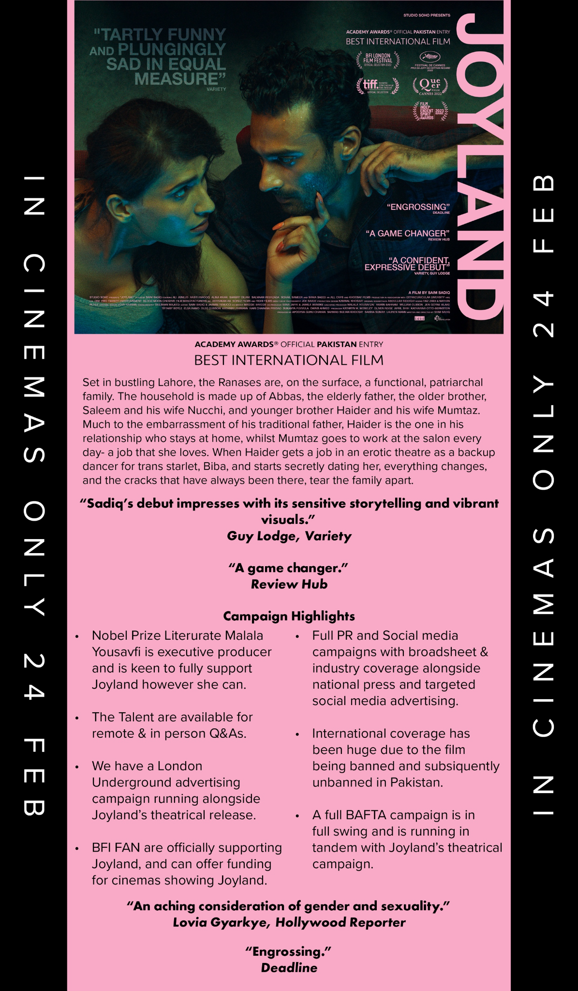

Assets
BFI FAN Programme Notes (by Asifa Lahore, Britain’s first out Muslim drag queen and LGBT+ activist): Download here
Official Website: https://www.studiosohodistribution.com/movie/joyland-1
Distributor Twitter handle: twitter.com/studiosoho_
Distributor press notes: Download here
UK posters: Download here
UK trailer: Download here / Youtube link
DCP trailer: Download here or here
30 second trailer: Download here
Social media marketing assets: Download here
Stills: Download here

Screener available on request. Contact: jordan@studiosohodistribution.com

Audience surveys
For feedback on the New Release title and your event, please direct your audience members to www.newreleasesurvey.co.uk to fill out our BFI FAN Audience Survey.
Responses can be shared with venues upon request.
- Easy Read feedback survey
- Download a MP4 slide here to put on your screens before the film to encourage audiences to fill out the survey.
- Download the QR code here
Simple and easy wins for exhibitors
- Facebook and Instagram ads: this is an easy and effective way at reaching target audiences. FAN support can pay for the ad and we can also talk you through campaign set-up to maximise results.
We expect Joyland to appeal to:
- Fans of world cinema
- LGBTQ+ cinema
- Trans rights groups
- Pakistan community/Asian film fans

Trans Community

I think this review from Autostraddle by a critic who I believe is trans is useful to read. The film does have problems in its approach to its trans character and cis programmers and freelancers probably should be aware of.

Joyland (dir. Saim Sadiq)

This is not a great trans film — but it is a great film with a trans lead. Saim Sadiq’s debut feature Joyland is more concerned with its queer male protagonist acting out his repressed desires through a trans woman than the trans woman herself. Usually this would bother me, but this movie is too good — and too respectful of that trans character — for me to care. There is room for all our stories, and considering this is only the second Pakistani feature I’ve ever seen, there is plenty new about this tale. And after all, most of us have had the experience of fucking someone who seems to have more interest in being us, or, at least, being as freely themself as they perceive us to be. Ultimately, that’s what this film is about: freedom. Freedom from our families, freedom from expectations.
If there was a canon of chaser cinema, this would be its masterpiece, but I’ll take a specific, delicate film about a “chaser” and his wife and family over what we usually get: poorly written trans media made by a chaser. It helps that Alina Khan gives an incredible performance as Biba, the trans character. It also helps that — unlike, say, Euphoria — the movie is very explicit about Biba’s womanhood and the man’s error in viewing her as a queer experiment. He may be queer, but Biba is a woman, and his interest in her is not what makes him queer. This is a beautiful, painful film about sexuality and gender, and, for once, the trans woman isn’t the recipient of that pain.
Young Audiences
In collaboration with distributors, the FAN Young Consultants (a group of 10 under 30 year olds working in film exhibition) select new release titles that they would like to highlight as particularly engaging for their peers and young people aged 16-30 (or segments therein). Working with the FAN Young Audiences lead Moira McVean, the group creates light-touch marketing packs with digital assets, eventising and social media marketing ideas aimed specifically at supporting exhibitors attracting younger audiences to their venues.

Feedback from the Young Consultants on Joyland:

Yasmin Begum: “Joyland is a timely film in its exploration of gender and sexuality. It’s a momentus time for Pakistani film creation and exhibition away from larger blockbusters and in addressing topic that are taboo.

I think Joyland will have a wide appeal across different groups because of the fact that it deals with issues and themes of sexuality and gender. Likewise, there is a growing number of people that are increasingly interested in world cinema. Pakistani film is hard to come by for a number of reasons, making Joyland stand out not only because of its acclaim at Cannes, but merely by existing.

The film is gorgeous, layered, textured, evocative, and it will hit a note for those with a lived experience of the LGBTQ community, or of growing up around topics and families like the ones that are portrayed in Joyland. As a third generation Welsh Pakistani person who is LGBTQ, this film was an emotional watch because of its portrayal of gender and sexuality, which was not something that was widely discussed.”

James Calver “This film finally delivered something for me at Cannes that had been missing up until that point – a poignant Queer story. What was originally sold to me as a terse drama focusing on the romantic relationship between a young man and a trans woman who works at the nearby erotic theatre turned out to be a beautiful and honest tale that was filled with laughter and tears. At its core, Joyland is a family drama, but it’s the performance of Alina Khan as Biba, the trans performer and erotic dancer, that overshadows everything else and elevates the film. All her scenes carry with them a poignancy that the others do not, and Khan truly rises to the occasion. It felt to me that Biba’s character was slightly underutilised in the closing act of the film, but that doesn’t do too much to detract from the whole piece. As in insight into a community that is rarely seen on screen in Europe, it was an amazing and contemplative experience.”

Feedback from students at the London College of Communications
The students are part of the BA (Hons) Film and Screen Studies at London College of Communication, University of the Arts, London.

Themes: LGBTQ+, Marriage, Romance, Self-Discovery, Betrayal, Identity, Pakistani Life, Social Norms, Culture, Queerness, Oppression, Patriarchy, Suffering, Family, Tradition, Suicide, Poverty, Depression

Audience sweet spot: 19-25
“I liked the film, it really took me by surprise. It showed the development of an ordinary guy & the struggles most trans women go through within different societies and places. It had a good balance of drama, dance and thrill which was what kept me drawn in.”
“Beautiful tragedy. i loved the cinematography and the costumes, very authentic. Babi was an iconic character.”
“A daring Pakistani debut centering on identity and what it means to be Pakistani. Joyland was a breath of fresh air from Pakistan, especially because the industry there likes to tiptoe around topics such and transgender identities.”
“People in the west often forget how hard it is to be your true self in the Global south as you give up so much because of culture. This film story allows us to see this perspective from the different family members and what happens when you put others before yourself.”
“Great film depicting society’s oppression of identity and how cultural traditions oblige one to conform. Great film.”
“A drama film about a man trying to find his way through complex relationships and strict societal pressure. The film was very emotional and provides a UK audience with an insight into a culture and community we don’t usually get to see on screen. The visuals and music are both really well done.”
Joyland: campaign and marketing ideas
The focus of BFI FAN’s support for new releases is developing diverse audiences:
- Price: If you have a young person/student ticket offer, why not promote it alongside Joyland
- Experience: Research into audiences highlights how important the whole experience is. Joyland is packed full of ideas - trans issues, society taboos, representation, etc
- Alternatively: Reach out to the distributor for a possible talent Q&A
- Themes: Focus on the fact that it is a film all about issues facing people today - discrimination, trans issues under threat etc
Promote your screenings
Find out how to tell new audiences about your events and make them unforgettable with our simple guides:
- A Simple Guide To: DIGITAL MARKETING: Marketing your events online can be as simple or as complex as you want it to be. To get you started, here are some easy steps to promote your event online.
- A Simple Guide To: AUGMENTING FILM SCREENINGS: Putting on a film screening doesn’t have to be about just showing a film. Venues can make their events stand out and attract new audiences by augmenting their screenings with something extra.
- Inclusive Cinema’s Guide to Being LGBTQI+ friendly in your cinema: Whether you are running a specific programme to engage with LGBTQ+ audiences or simply hoping to grow LGBTQ+ representation in your existing screenings, it’s really important to remember some key things to make sure you are sensitively and appropriately programming, promoting, and welcoming audiences in your cinema.
  - LGBTQ+ national, regional & film organisations.xlsx

If running social media advertising, consider using the following key words/phrases to attract diverse audiences that might be interested in the film:
- Trans film
- LGBTQ cinema
- LGBTQ cinema/Queer film/Intersex film
- Pakistan film
Event Ideas
With thanks to Young Consultant Yasmin Begum for sharing her insight and the following ideas.

Q&A event/collaboration with Gaysians
This film being from the global south and with a trans focus can allow for some really interesting programming relating to potential speakers.
For instance, there could be the opportunity to approach organisations like Gaysians who highlight and support LGBTQ voices in the Asian community
These groups both serve minority ethnic communities who are from the LGBTQ community. Within this plan, there is the opportunity to discuss both race or ethnicity or heritage alongside LGBTQIA topics to bring both together within an intersectional framework.
This film is also, broadly, a film about LGBTQIA identity that happens to be set in Pakistan. It’s part of a shift within film towards the representation of underrepresented communities, and the family being Muslim, being Panjabi, speaking Panjabi and Urdu are layers to this work.
Alongside approaching LGBTQIA organisations that serve minority ethnic communities, there is an opportunity to approach, broadly speaking, other LGBTQIA groups. These groups could be in a cinema’s local area, such as Pride organisations, Stonewall, and other groups that serve specific areas. In Wales, groups to approach would be Glitter, a BAME LGBTQ organisation, and the Welsh Ballroom Community. If the cinema is in a university town, potential speakers could be local LGBTQIA activists or people from LGBTQ groups overall. Pakistani people and those in the Pakistani diaspora and/or Panjabi diaspora may be of particular interest to invite as speakers because of the film’s location in Lahore, Panjab, combined with the Partition of India in 1947.
Engagement and Outreach
For a while, it was unclear if Joyland would have a UK-wide distribution. Most films from South Asia that are exhibited within Britain are from the wider industries of Bollywood and larger blockbusters compared to independent cinema. Pakistan doesn’t have a great wealth of independent cinema, for various reasons. There will be groups who may not regularly attend the cinema or engage with its services- say, if there’s a cafe there or something similar- but may consider attending a showing like this.
Therefore, personal invitations ought to be distributed to groups and where the groups engage with different communities, consideration given to whether or not the cinema can afford to comp tickets to community groups as a gesture of goodwill. Long-term, this will yield, potentially, different communities coming into the cinema and a wider knowledge of the cinema and its programming.
Food
Alongside the above, there could be an opportunity to have catering after a showing with a question and answer session. Pakistani food is really popular in the United Kingdom, even if a lot of it has been cooked under the guise of British Indian Restaurant cooking. Samosas, pakoras, lassi, small finger foods and drinks, there’s no need for anything particularly heavy or for a sit-down meal. It could be themed as part of an evening with Joyland. Joyland could be paired with some other shorter films, but maybe not, given its length and the best interests of audience comfort relating to diverse audiences. Sometimes, it’s intense to sit there for over two hours, and Joyland is just over two hours as a film. Local Film Hubs and organisation can support with funding to cover eventising any catering or to cover the cost of any speakers fees.
Audience
The target audience for this film vary. In terms of age, it's anyone above 16 years old. For people in the Pakistani or South Asian diaspora, it could be everyone because of the fact that it's a Pakistani film in Urdu and Panjabi. For LGBTQIA people and allies, this film will be of interest to different ages from 16-30 or to all because of the subject matter, which is underscored by the fact that it's from Pakistan. That could be a bit of a novelty because of a lack of independent cinema from Pakistan and the illegality of homosexuality within Pakistan, and a lack of information about hijra communities in Britain. For cinemas serving areas with a larger South Asian diaspora than average, the audience varies across race, class, sex, and gender because of the relationship that the South Asian diaspora shares to the population overall in Britain. South Asian people are the largest ethnic minority community, and in places such as South Birmingham, there are areas with higher proportions of Pakistani people and Kashmiri people. This film is at the intersection of audience development and conversations on equality, which allows for a potential for some fascinating audience development and engagement relating to this title in an organic manner.

Potential Guest Speakers
If you’re booking to book speakers or commission writers or any workshops or anything relating to the title, these people could be potential people to email relating to their work and their capacity. This is a list of people who are South Asian in Britain or who have South Asian heritage as part of the Black, Asian, and Minority Ethnic community and who are also LGBTQIA people, so their identity sits at the confluence of ethnicity/race/heritage, and of sexuality and gender. This is a bit of a double whammy, as we are in the habit in exhibition of discussing one characteristic because of the public sector equality duty, but not looking at say, where communities with different protected characteristics coalescence
● Sabah Choudhrey, a writer, campaigner, and activist who is British-Pakistani and trans who has written substantially on both race and trans identity in Britain
● Asifa Lahore, a British Pakistani drag queen who is LGBTQIA
● Saima Razzaq, British Pakistani activist and campaigner and Head of Diversity and Inclusion Engagement at Birmingham Pride
● Shash Appan, British-Tamil trans anti racist activist, writer, and campaigner founder of Trans Mutual Aid Cymru based in Wales
● Alia Ramna, a Welsh Pakistani trans woman and dancer with the Welsh Ballroom Community

Planning your event
There is a regional marketing freelancer in each Film Hub region working on grassroots outreach, press and marketing, alongside a small budget for activity. They will also be working with students (both foreign and home) and language schools. Get in touch on fannewreleases@watershed.co.uk to be linked in to the campaign in your area - we can help with event ideas, finding speakers and other grassroots marketing.
- Email template for schools/university/youth networks
- Email template for event screenings
- Email template for contacting venues

Press
Get in touch with local press for any special events with the below press release template alongside stills from the film.
- Generic press template for local press and listings

Key Press Quotes
Rotten Tomatoes critic reviews
“Sadiq's debut impresses with its sensitive storytelling and vibrant visuals.” - Guy Lodge, Variety
“Joyland marks a strong debut, not just for its director Saim Sadiq but for Pakistani cinema at large at the Cannes Film Festival.” - Namrata Joshi, National Herald (India)
“It’s a bittersweet and melancholic interrogation of sexuality and gender roles that pulls very few punches.” - Robert Daniels, RogertEbert.com
“Sadiq’s screenplay navigates a complex web of secrets and lies, pressures and prejudices to create a soulful human drama intent on challenging narrow minds” - Screen Daily

“Joyland is a family saga, one that Sadiq uses to observe how gender norms constrict, and then asphyxiate, individuals.” - The Hollywood Reporter

“A thoughtful, well performed and engrossing drama.” - Deadline

Awards
It had its world premiere at the 2022 Cannes Film Festival on 23 May 2022 in Un Certain Regard, where it competed for the Caméra d'Or.
Joyland is the first Pakistani film to premiere at Cannes Film Festival and it received a standing ovation after its screening, and also won Jury Prize and Queer Palm prize for best LGBTQ, queer or feminist theme movie at the festival.
- LFF – Sutherland Award – Special Commendation
- TIFF – Official Selection
- Academy Awards – Best International Feature - Official Entry Pakistan
- Athens International Film Festival – Winner Best screenplay
- Valladolid Film Festival – Winner Audience Award
- Sao Paulo Film Festival – Winner Best Actor

Articles of Interest
- The Bigger Picture: Why cinemas should consider programming Joyland this LGBT+ History Month by Yasmin Begum
- The Bigger Picture: How Joyland will transform the perception of Pakastani cinema in the UK by Yasmin Begum
- PINK NEWS - Joyland: Trans film executive produced by Malala Yousafzai banned after ‘complaints’ in Punjab
- ‘Joyland’ eligible for international Oscar thanks to upcoming France release
- The Guardian - Joyland: Pakistan bans Oscar contender film about trans love affair
- The Guardian - ‘Everyone should see it’: embattled film Joyland opens in Pakistan

Interview Coverage

Screen Daily – Interview with Director
https://www.screendaily.com/features/director-saim-sadiq-on-tackling-taboos-in-joyland-the-first-pakistani-film-ever-in-cannes-official-selection/5170966.article

Deadline – Director & Producer
https://deadline.com/video/joyland-saim-sadiq-apoorva-guru-charan-video-interview-cannes-studio/

Film & TV NOW – Interview with Producer
https://www.filmandtvnow.com/interview-special-oliver-ridge-corner-office-joyland/

FirstPost – Interview with Director
https://www.firstpost.com/entertainment/cannes-2022-i-have-been-living-with-joyland-for-seven-years-says-director-saim-sadiq-10730261.html

Sample social media post

