Neptune Frost
Marketing Pack for venues, part of BFI FAN’s support for new releases “The film is a critique of the capitalist ravages visited on Burundi and its neighbours by a technology-obsessed society. It’s also a soaring, poetic vision of a transformative future, filled with abstract scenes of singing and partying.”
David Sims, The Atlantic
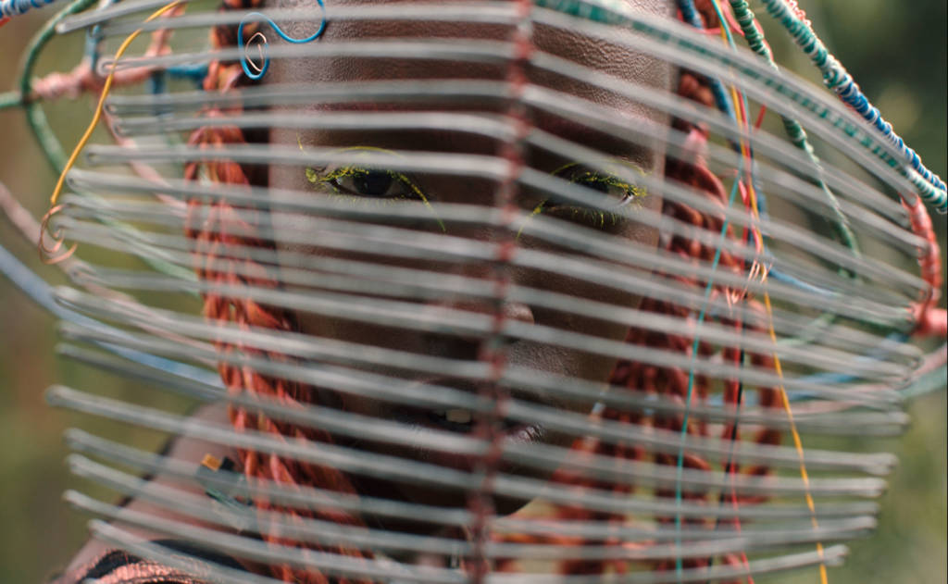
Specification details:
Dir. Saul Williams, Anisia Uzeyman | Cert. TBC | 105 mins | US/Rwanda | 2021
Distributor: Anti Worlds
Available: 4 November 2022
Booking: theatrical@anti-worldsreleasing.co.uk
- HoH and Audio Descriptive versions of the film are available to book.

Logline:
Afrofuturist fantasia Neptune Frost, is a wondrous, thrilling sci-fi punk musical from multi-hyphenate, multidisciplinary artists Saul Williams and Anisia Uzeyman.

Synopsis:
Multidisciplinary artists Saul Williams and Anisia Uzeyman bring their unique dynamism to the Afro-futurist vision of Neptune Frost.
It is a sci-fi-punk musical that’s a visually wondrous amalgamation of themes, ideas, and songs that they have been exploring in their work, including on Williams’ 2016 album MartyrLoserKing.
Neptune Frost takes place in the hilltops of Burundi, where a group of escaped coltan miners camp in an otherworldly e-waste dump, they attempt a takeover of the authoritarian regime exploiting the region’s natural resources –and its people. When an intersex runaway and an escaped miner find each other through cosmic forces, their connection sparks glitches within the greater divine circuitry.
Set between states of being – past and present, dream and waking life, colonised and free, male and female, memory and prescience – Neptune Frost is an invigorating and empowering direct download to the cerebral cortex and a call to reclaim technology for progressive political ends.
Assets
BFI FAN Programme Notes by Edson Burton: Download here
Official Website: https://anti-worldsreleasing.co.uk/
Distributor Twitter handle: https://twitter.com/anti_worlds
UK posters: Download here
UK trailer (inc. DCP): Download here
Stills: Download here
Press notes: Download here

Screener available on request. Contact: Andy Starke <andystarke@gmail.com>

Audience surveys
For feedback on the New Release title and your event, please direct your audience members to www.newreleasesurvey.co.uk to fill out our BFI FAN Audience Survey.
Responses can be shared with venues upon request.
- Easy Read feedback survey
- Download a MP4 slide here to put on your screens before the film to encourage audiences to fill out the survey.
- Download the QR code here
Simple and easy wins for exhibitors
- Facebook and Instagram ads: this is an easy and effective way at reaching target audiences. FAN support can pay for the ad and we can also talk you through campaign set-up to maximise results.
We expect Neptune Frost to appeal to:
- Science Fiction fans/Afro-futurism
- Musicals
- Black cinema
- LGBTQ+ cinema
- Political/left wing/socialist groups
- Environmental groups (Extinction Rebellion)

Potential Guest Speakers
If you’re looking for potential guest speakers or people to write blog posts/articles about afro-futurism, African cinema, anti-capitalism or any of the many themes in the film, here are some recommended subject matter experts:

- Dr Chisomo Kalinga (who has previously worked for Oprah Winfrey, reviewed a book on love,money, and HIV, and currently working on several book projects)
- Dr. Leighan Renaud (whose work focuses on matrifocality in African-Caribbean families and literature)
- Khadijah Diskin (who wrote these brilliant pieces on policing and schooling, and hotepry in the Black community)
- Dr. Hannah Robbins (who wrote a viral critique on Hamilton for The Conversation)
- Janine Francois (who has written about everything from radical rest to Nottinghill Carnival; Black British pop girl groups and decolonisation of museums)
- Furaha Asani (writer and pop culture critic myself) who has written film critique such as, "When Disney's first 'African' princess looked nothing like me".
- Imwen Eke: An Experience Designer, Social Games practitioner and Creative Technician. She tours the sensorium of technology, participatory performance and gameplay to explore new conversations and narratives for culturally curious audiences. Her practice was born from the curiosity to examine interactions happening online with the impulse to make something better equipped to expand those conversations in real life. Her practice has been influenced by working in production for SHUNT, Punchdrunk and residencies with Blast Theory, Bryony Kimmings, B3 Talent Lab and LIFT Festival. Imwen creates work through her Games studio New Party Rules Labs and is a resident of the Pervasive Media Studio in Bristol, a tutor of the University of the Underground, a Lecturer at ISCOM, Paris and co-founder of the Livesey Exchange, a new business and cultural arts centre in South London.
Young Audiences
In collaboration with distributors, the FAN Young Consultants (a group of 10 under 30 year olds working in film exhibition) select new release titles that they would like to highlight as particularly engaging for their peers and young people aged 16-30 (or segments therein). Working with the FAN Young Audiences lead Moira McVean, the group creates light-touch marketing packs with digital assets, eventising and social media marketing ideas aimed specifically at supporting exhibitors attracting younger audiences to their venues.

Feedback from the Young Consultants on Neptune Frost
Themes
Sci Fi, community, friendship, gender fluidity, ethics, anti-authoritarian/activism, technology, pan Africanism, anti-colonialism, loss, religion, coming of age, rebellion

Comparison titles
Dune, I Robot, Black Panther

Age sweet spot – 19-25

Selling points
Cinematography, Sci-Fi punk, LGBTQIA+, music, costume

Alex Goldsmith
“In a word: Mesmerising. Neptune Frost is truly cinema in poetry, a visually (and aurally) stunning work of art that feels like it should be on display in a museum. Set in Rwanda, this film is about a community of hackers taking a stand against the countries (and wider worlds) discrimination and marginalisation and it is absolutely anything but traditional, with a narrative weaved through song and spectacle, it’s a hypnotising musical odyssey. Early on, there is a song called “Binary Stars” (by artist Saul Williams) which is paired with a poetic monologue about ‘Hacking’, and the scene is absolutely bewitching. It takes a lot of imagination when watching, and a lot the films ideas and statements undoubtedly went over my head, but I still found it to be a very powerful film that contains a strong message about the strength of solidarity at its core.”

Louise Giadom
“The music is great, really catchy and the way they've incorporated that with the visual storytelling is something we don't get in movies a lot. It's a very artistic film, many scenes feel like visual poetry and it's engaging and draws your attention. It actually feels a lot like a music video to me which helps to make the fact it's hard to follow plot-wise easier to handle. I think this will be great for audiences who prefer niche, visual story told films. Definitely something I can see young audiences enjoying with the right marketing because you have the music - specifically rap - to dig deeper into.”

Thea Berry
“I found this utterly captivating and I've never seen anything quite like it. The music and poetry are beautiful and powerful, and while this feels totally of now and contemporary it speaks to the culture of storytelling and oral histories across African countries. This is one that needs to be seen in the cinema.”

Neptune Frost: campaign and marketing ideas
The focus of BFI FAN’s support for new releases is developing diverse audiences:
- Price: If you have a young person/student ticket offer, why not promote it alongside Neptune Frost
- Experience: Research into audiences highlights how important the whole experience is. Neptune Frost is packed full of ideas - environmental, social, political and with great music, so you can tailor your screenings around these themes or simply celebrate it as one of the most unique sci-fi films of recent years.
- Alternatively: Reach out to the distributor for a possible talent Q&A
- Themes: Focus on the fact that it is a film all about issues facing people today - natural resources being mined, capitalism out of control, fear of the future and politics and technology colliding.
Promote your screenings
Find out how to tell new audiences about your events and make them unforgettable with our simple guides:
- A Simple Guide To: DIGITAL MARKETING: Marketing your events online can be as simple or as complex as you want it to be. To get you started, here are some easy steps to promote your event online.
- A Simple Guide To: AUGMENTING FILM SCREENINGS: Putting on a film screening doesn’t have to be about just showing a film. Venues can make their events stand out and attract new audiences by augmenting their screenings with something extra.
If running social media advertising, consider using the following key words/phrases to attract diverse audiences that might be interested in the film:
- Afro-futurism
- Environmental cinema
- African cinema
- LGBTQ cinema/Queer film/Intersex film
- Anti-Capitalism
Event Ideas
- Partner with local environmental groups (Extinction Rebellion)
- Outreach to local Afro-futuristic/sci-fi groups
- Link it to the upcoming Black Panther film which also has themes of afro-futurism and progressive political views for black culture
- Q&A with writer/director/star - pre-recorded options to be made available
- Guest speaker on the many, many themes of the film
- Collaborations with Africa Film Festivals such as Africa in Motion

Planning your event
There is a regional marketing freelancer in each Film Hub region working on grassroots outreach, press and marketing, alongside a small budget for activity. They will also be working with students (both foreign and home) and language schools. Get in touch on fannewreleases@watershed.co.uk to be linked in to the campaign in your area - we can help with event ideas, finding speakers and other grassroots marketing.
- Email template for schools/university/youth networks
- Email template for event screenings
- Email template for contacting venues

Press
Get in touch with local press for any special events with the below press release template alongside stills from the film.
- Generic press template for local press and listings

Key Press Quotes
Rotten Tomatoes critic reviews
““Neptune Frost” is a reminder of cinema’s infinite storytelling possibilities” - RogerEbert.com
“It’s a difficult movie to describe with any elegance, which is a good thing, because what’s enriching about it exists more powerfully in images than in speech.” - Rolling Stone
“Enchanting and immersive... a war cry that’s simultaneously a galvanizing call to action, a message of hope and a reminder that a different world is possible.” - Los Angeles Times
“The film is a critique of the capitalist ravages visited on Burundi and its neighbours by a technology-obsessed society. It’s also a soaring, poetic vision of a transformative future, filled with abstract scenes of singing and partying.” - The Atlantic

Awards
Neptune Frost had its world premiere on July 8, 2021. at the Directors' Fortnight section at the 2021 Cannes Film Festival, where it was a nominee for the Queer Palm

Articles of Interest
- AV Club: Neptune Frost features bold colors—and bolder ideas
- The Verge: Neptune Frost’s radical sci-fi future
- The Hollywood Reporter: ‘Neptune Frost’ Directors on the Visionary Sci-Fi Musical Being “An Expression of How Revolution Starts”
- Polygon: Neptune Frost’s first trailer offers a glimpse at Saul Williams’ boundary-pushing Afropunk sci-fi musical
- Rolling Stone: ‘Neptune Frost’: An Afrofuturist Dreamscape Musical (!) Takes Capitalism to Task
- The Spool: Neptune Frost is a haunting slice of sci-fi musical Afrofuturism
- Hyper Allergic: The Afrofuturist Musical Romance of Neptune Frost
- Original Cin: Neptune Frost: Anti-Colonial, Gender-Fluid Political Rave Up Boasts Triumphant Imagery
- WDET: “Neptune Frost” is an Afro-futuristic musical unlike anything you’ve seen

Sample social media post

“Neptune Frost is a reminder of cinema’s infinite storytelling possibilities” - @ebertchicago
Make sure to check out afrofuturist fantasia Neptune Frost from multi-hyphenate artists @SaulWilliams and @dreamstatesmeta.
Book your tickets for the @anti_worlds film now: LINK

