Queen of Glory
Marketing Pack for venues, part of BFI FAN’s support for new releases
“Queen of Glory is about Sarah Obeng confronting her past when everything falls apart, enduring the pain that follows, and allowing herself to be surprised— even delighted— by what she finds there. I had no idea how much endurance would factor in realizing this film. And how much endurance would matter in 2021, when the creative team and I decided this film was ready for the world.”
Nana Mensah, writer / director: Queen of Glory
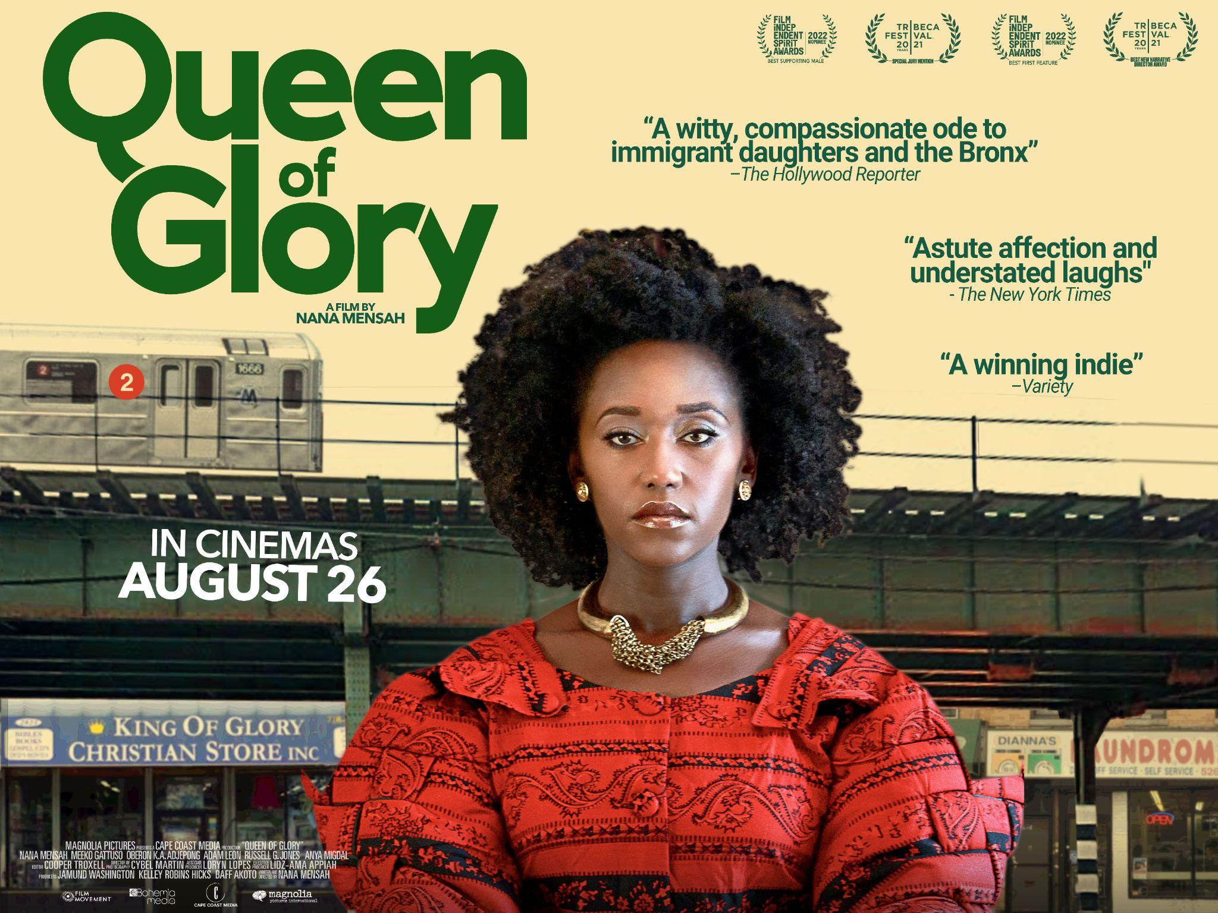
Specification details:
Dir. Nana Mensah | Cert. 15 | 78 mins | US | 2021
Distributor: Bohemia Media
Available: 26 August 2022
Booking: Delphine Lievens (she/her), Head of Distribution | Bohemia Mediae. delphine@bohemiamedia.co.uk
- HoH and Audio Descriptive versions of the film are available to book.

Logline:
Ghanaian-American Sarah is all set to abandon her Ivy League doctoral program to follow her married lover across the country when her mother dies suddenly and makes her the owner of a neighborhood bookshop in the Bronx.
Synopsis:
'Queen of Glory' is the story of Sarah Obeng, the brilliant child of Ghanaian immigrants, who is quitting her Ivy League PhD program to follow her married lover to Ohio. When her mother dies suddenly, she bequeaths her daughter a Christian bookstore in the Pelham Parkway section of the Bronx where Sarah was raised. A follow-up on the classic immigrant's tale, Queen of Glory provokes laughter and empathy, as its heroine is reborn through her inheritance.

Assets
Pre-recorded Q&A: TBC
BFI FAN Programme Notes (written by Tomiwa Folorunso): Download here
Official Website: https://www.bohemiamedia.co.uk/film/queen-of-glory/
Distributor Twitter handle: https://twitter.com/BohemiaMediaUK
Nana Mensah Twitter handle: https://twitter.com/itsnanamensah
US production notes: Download here
UK posters: Download here
UK trailer: Download here
Stills: Download here
Social media assets: Download here
Vox pops: Download here

Screener available on request. Delphine Lievens (she/her), Head of Distribution | Bohemia Media. delphine@bohemiamedia.co.uk
Audience surveys
For feedback on the New Release title and your event, please direct your audience members to www.newreleasesurvey.co.uk to fill out our BFI FAN Audience Survey.
Responses can be shared with venues upon request.
- Easy Read feedback survey
- Download a MP4 slide here to put on your screens before the film to encourage audiences to fill out the survey.
- Download the QR code here
Simple and easy wins for exhibitors
- Facebook and Instagram ads: this is an easy and effective way at reaching target audiences. FAN support can pay for the ad and we can also talk you through campaign set-up to maximise results.
We expect Queen of Glory to appeal to:
- Immigrant communities, especially the Ghanian community
- Lovers of mother/daughter dramas
- Female film-makers
- Coming of age dramas
- Christian church groups

Young Audiences
In collaboration with distributors, the FAN Young Consultants (a group of 10 under 30 year olds working in film exhibition) select new release titles that they would like to highlight as particularly engaging for their peers and young people aged 16-30 (or segments therein). Working with the FAN Young Audiences lead Moira McVean, the group creates light-touch marketing packs with digital assets, eventising and social media marketing ideas aimed specifically at supporting exhibitors attracting younger audiences to their venues.

Feedback from the Young Consultants on Queen of Glory

Louise Giadom
“I enjoyed the film. I thought it was great to see something about that culture and it was a really touching story of her kind of finding her roots and herself. I think it hit all the bases, it was funny, emotional, had some great advice in there too. It's solid entertainment and a nice, pleasant watch. Also it was really great to actually get to watch a diverse-led film that was more wholesome than anything else.”

Caroline Wilson
“I liked this film too. I think it definitely is for a female audience and touched really nicely on reconnecting with your culture and taking a break to sort out your life and find yourself. A highlight for me in the film was the scenes in the Christian bookshop between Nana Mensah and Meeko. They both have great chemistry and are effortlessly great on screen. It's also great to see New York on screen depicted as it really is. I think this film serves as a great platform for writer/director Nana Mensah and is an enjoyable watch for a millennial audience.”

Colette Webber
“It’s a sweet and simple formula which I did really enjoy at times, and it made me laugh…it’s directed in a really warm and honest style which highlights a New York that we don’t always see on screen. I think it would go down well with young women in particular.”

Yasmin Begum
“I really enjoyed it. It really reminded me of the dynamic I have with my own family, sans STEM PhD, or Christian bookshop, or death of a parent. I really value films that look at loss and whatnot because we don't see a lot of portrayals of loss and death from BAME communities beyond Muslim South Asian communities or occasionally Hindu or Sikh communities. I think it's so important for people to say 'yeah, that's how we do it, and all'.

My Dad would really like this film: he's 48, works as a cook in a takeaway, a second generation Pakistani migrant [much like Mensah's character re: being Ghanian), and has an experience of going to prison. I could see him watching this and this really touching home for him. I rarely see stuff and think "Yeah, my parents would like this, as well as me". We don't get too many films that explore what life is like after prison.”

Queen of Glory: campaign and marketing ideas
The focus of BFI FAN’s support for new releases is developing diverse audiences:
- Price: If you have a young person/student ticket offer, why not promote it alongside Queen of Glory
- Experience: Research into audiences highlights how important the whole experience is. Think about about a possible singles night due to the film’s romantic plotline or a music tie-in due to its eclectic soundtrack. The Young Consultants also suggest a themed food offer. Perhaps there’s a Ghanaian restaurant or caterer in your area?
- Alternatively: Reach out to the distributor for a possible talent Q&A
- Interaction / social media: Focus on the fact that it is a film all about issues facing people today - disconnection, loneliness and people just looking to connect.
Promote your screenings
Find out how to tell new audiences about your events and make them unforgettable with our simple guides:
- A Simple Guide To: DIGITAL MARKETING: Marketing your events online can be as simple or as complex as you want it to be. To get you started, here are some easy steps to promote your event online.
- A Simple Guide To: AUGMENTING FILM SCREENINGS: Putting on a film screening doesn’t have to be about just showing a film. Venues can make their events stand out and attract new audiences by augmenting their screenings with something extra.
If running social media advertising, consider using the following key words/phrases to attract diverse audiences that might be interested in the film:
- Ghanian community/culture
- Drama
- Black cinema
Event Ideas
- Partner with local bookshop/church group
- Outreach to local Ghanian population or local immigrant groups
- Q&A with writer/director/star - pre-recorded options to be made available
- Food tie-in with authentic Ghanian food
- Collaborations with Africa Film Festivals such as Africa in Motion

Planning your event
There is a regional marketing freelancer in each Film Hub region working on grassroots outreach, press and marketing, alongside a small budget for activity. They will also be working with students (both foreign and home) and language schools. Get in touch on fannewreleases@watershed.co.uk to be linked in to the campaign in your area - we can help with event ideas, finding speakers and other grassroots marketing.
- Email template for schools/university/youth networks
- Email template for event screenings
- Email template for contacting venues

Press
Get in touch with local press for any special events with the below press release template alongside stills from the film.
- Generic press template for local press and listings

Key Press Quotes
Rotten Tomatoes critic reviews
“At its core, Mensah's tightly conceived, witty and compassionate dark comedy is a love letter to children of Ghanaian immigrants and to the Bronx, the borough in which she and her protagonist grew up.” - The Hollywood Reporter
“Queen of Glory is a confident, vibrant debut from writer, director, and star Mensah.” - One Room With A View
“Masterfully uses dilemmas of culture and selfhood to craft a wonderful, intimate story of discovery. Both behind the camera and in front of it, Mensah is incredible to watch.” - The Indiependent
“With a lived-in feel for the Bronx community in which her story takes place, the filmmaker generates endearing pathos from a story whose familiarity is offset by its humor and authenticity.” - Variety
“Amusing and astute feature debut” - NY Times

Awards
- Queen of Glory premiered at the 2021 Tribeca Film Festival U.S. Narative Competition.
- Mensah won Best New Narrative Director and Special Jury Prize for Artistic Expression. In February 2022
- The film also premiered at the 2021 Film Independent Spirit Awards and was nominated for Best First Feature.
- It won numerous film festival prizes, including two awards from the Champs-Élysées Film Festival and the inaugural California Film Institute's Mind the Gap Creation Prize.
Articles of Interest

‘Queen of Glory’ Review: A Winning Indie About Immigrant Identity

BWW Interview: Nana Mensah Talks NOLLYWOOD DREAMS, QUEEN OF GLORY & More
- Nana Mensah On Her Directorial Debut 'Queen Of Glory,' Netflix's 'The Chair' & Doing It All

Sample social media posts

“Queen of Glory is a confident, vibrant debut from writer, director, and star Mensah.” - One Room With A View
Check out the new film from @itsnanamensah - Queen of Glory from @bohemiamediauk - out at (venue date) from 26 August.
TICKET LINK

A follow-up on the classic immigrant's tale, Queen of Glory is a wonderful directorial debut from actor/writer/director @itsnanamensah.
The @bohemiamediauk film hits UK cinemas on 26 August. Get your tickets here.
TICKET LINK

