A Fantastic Woman
Marketing Pack for venues, part of the BFI FAN New Release Strategy
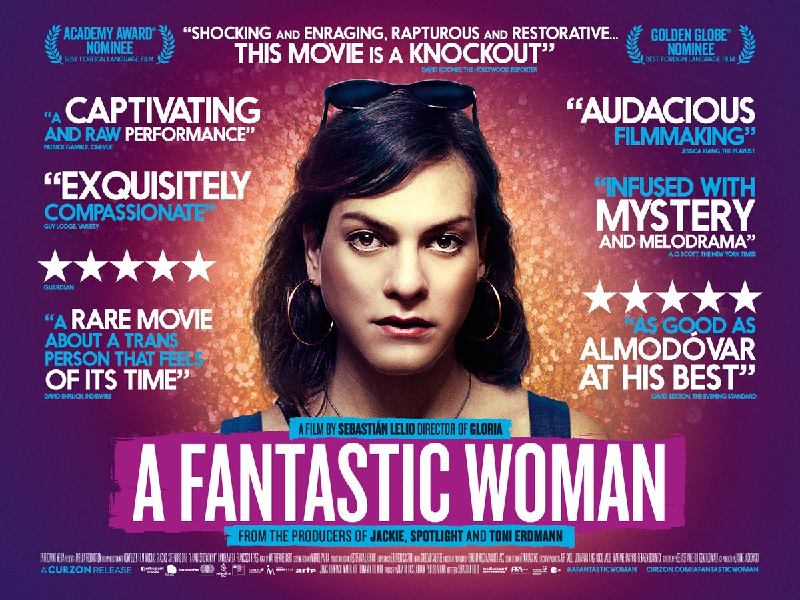
Specification details:
A Fantastic Woman
Spain, Chile, Germany, USA / 2017
Dir. Sebastián Leilo
104 mins
BBFC Cert. 15
Cast includes: Daniela Vega

Distributor: Curzon
Available: 2 March (theatrical); 21 May (non-theatrical, one-offs etc)
Booking: james.king@curzon.com

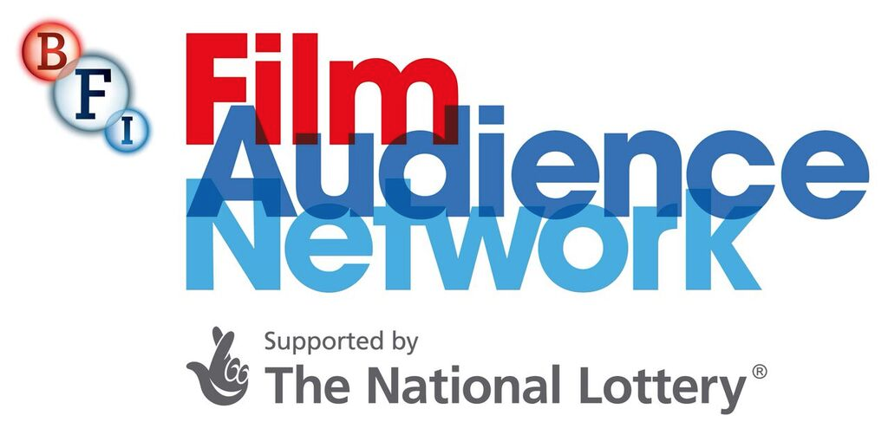
Community cinemas can book A Fantastic Woman via BFI (from 21 May on Blu-Ray).
Please contact them on:
bookings.films@bfi.org.uk / 020 7957 8938

Awards:
2018 Oscar nominee for Best Foreign Language Film
2018 Golden Globe nominee for Best Motion Picture - Foreign Language

Official Facebook: http://www.facebook.com/AFantasticWoman
Official Twitter: http://twitter.com/ArtificialEye
Talent twitter socials: @Slelio, @danivega
Official hashtag: #AFantasticWoman
Official Instagram: @artificialeyefilm

Listings site: http://afantasticwoman.co.uk/
Distributor site: https://www.curzonartificialeye.com/a-fantastic-woman/

Trailer YouTube link: https://youtu.be/s11pPHXwEFU
Trailer Download: Available on request – email avalon.lyndon@curzon.com
Stills/images
Poster
Social Media Assets: TBC – will be available on the shared folder

Download press pack: includes interviews with Daniela Vega & Sebastian Leilo

Events and marketing ideas
The focus of BFI FAN’s New Release Strategy is developing audiences aged 16-30. If you’re interested in making more of an event of your screening, or looking for ideas to reach out to audiences this age and beyond, click here for campaign and event ideas.

Your Film Hub has a budget to support marketing activity for A Fantastic Woman - get in touch with your ideas and see what support they can offer.

E-mail template for LGBT/Youth networks
E-mail template for event screenings
E-mail template for Spanish language classes and clubs

Press
Get in touch with local press for any special events with the below press release template alongside stills from the film.

Generic press template for local press and listings

Key Press Quotes

“It may be a timely film, but it is its timelessness, as well as its depths of compassion, that qualify it as a great one.” ★★★★★ – Ryan Gilbey, The Guardian

“Shocking and enraging, rapturous and restorative… This movie is a knockout” David Rooney, The Hollywood Reporter

“A captivating and raw performance [from Daniela Vega]” ★★★★★ – Patrick Gamble, CineVue

“As good as Almodóvar at his best” ★★★★★ – David Sexton, The Evening Standard

“A rare movie about a trans person that feels of its time” – David Ehrlich, Indiewire

Film Copy

Official synopsis
Gloria director Sebastián Lelio returns with A Fantastic Woman, a groundbreaking, captivating and deeply humane story about a trans woman’s fight for acceptance. Anchored by a powerhouse central performance from rising star Daniela Vega, this Oscar-nominated film is an urgent call for compassion towards a community that faces bigotry and hostility on a daily basis.

Vega plays Marina Vidal, a young singer whose life is thrown into turmoil following the sudden death of her partner, Orlando. Met with suspicion from the police and contempt from her lover’s relatives, Marina finds herself placed under intense scrutiny, with no regard for her privacy, or her grief. As tensions rise between Marina and Orlando’s family, she is evicted from their shared home and banned from attending his funeral. But faced with the threat of losing everything, Marina finds the strength to fight back.

From the producers of Jackie, Spotlight and Toni Erdmann, A Fantastic Woman is an outstanding, timely work that recalls the very best films of Pedro Almodóvar. Soaked in luminous visuals and elevated by elegant flights of surrealism, it is a courageous, audacious and defiant declaration of Marina’s status as a woman – and a fantastic one, at that.

30 words
A captivating and life-affirming story about a trans woman’s fight for acceptance, Oscar-nominated A Fantastic Woman is an urgent call for compassion towards a community that faces bigotry every day.

50 words
A groundbreaking, captivating and life-affirming story about a trans woman’s fight for acceptance. Anchored by a powerhouse central performance from rising star Daniela Vega, the Oscar-nominated A Fantastic Woman is an urgent call for compassion towards a community that faces bigotry and hostility on a daily basis.

80 words

The Oscar-nominated A Fantastic Woman is a groundbreaking, captivating and life-affirming story about a trans woman’s fight for acceptance, anchored by a powerhouse central performance from rising star Daniela Vega.

Vega plays Marina Vidal, a young singer whose life is thrown into turmoil following the sudden death of her partner. Facing harassment and suspicion from both her partner’s family and the authorities, A Fantastic Woman is a defiant declaration of Marina’s status as a woman – and a fantastic one, at that.

100 words

A groundbreaking, captivating and life-affirming story about a trans woman’s fight for acceptance, anchored by a powerhouse central performance from rising star Daniela Vega.

Vega plays Marina Vidal, a young singer whose life is thrown into turmoil following the sudden death of her partner, Orlando. Met with suspicion from the police and contempt from her lover’s relatives, Marina finds herself placed under intense scrutiny, with no regard for her privacy, or her grief.

Oscar-nominated and widely adored, A Fantastic Woman is a courageous, audacious and defiant declaration of Marina’s status as a woman – and a fantastic one, at that.

Sample Tweets

Attach stills/trailer where possible and remember to use #AFantasticWoman
Trailer YouTube link: https://youtu.be/s11pPHXwEFU
Trailer Download: Available on request – email avalon.lyndon@curzon.com
Stills/images

Oscar-nominated and widely adored, find out what makes #AFantasticWoman just so fantastic when it comes to [VENUE] on [DATE]

“As good as Almodóvar at his best” ★★★★★ says @EveningStandard, don’t miss this Chilean gem when it comes to [VENUE] on [DATE]

“A rare movie about a trans person that feels of its time” says @IndieWire, don’t miss #AFantasticWoman when it shows here from [DATE]

A captivating and life-affirming story about a trans woman’s fight for acceptance, Oscar-nominated #AFantasticWoman comes to UK cinemas from 2 March

Whether you call her Una Mujer Fantástica or #AFantasticWoman, discover the magic of Marina when this Oscar-nominated gem hits cinemas from 2 March

Sample Facebook Posts:

Attach stills/trailer where possible and remember to use #AFantasticWoman
Trailer YouTube link: https://youtu.be/s11pPHXwEFU
Trailer Download: Available on request – email avalon.lyndon@curzon.com
Stills/images

Oscar-nominated and widely adored, find out what makes #AFantasticWoman just so fantastic when it comes to [VENUE] on [DATE]

A groundbreaking, captivating and life-affirming story about a trans woman’s fight for acceptance, with a powerhouse central performance from rising star Daniela Vega, A Fantastic Woman is an urgent call for compassion towards a community that faces bigotry and hostility on a daily basis.

****

We’re delighted that new Chilean film A Fantastic Woman - about a young transgender woman struggling to live with grief and the prejudice she suffers after the death of her lover - opens here on [DATE]

Check out the trailer below to get a flavour of the INCREDIBLE performance by Daniela Vega and you’ll see why A Fantastic Woman was nominated for the Best Foreign Film Oscar - fingers crossed!

Book tickets here:

