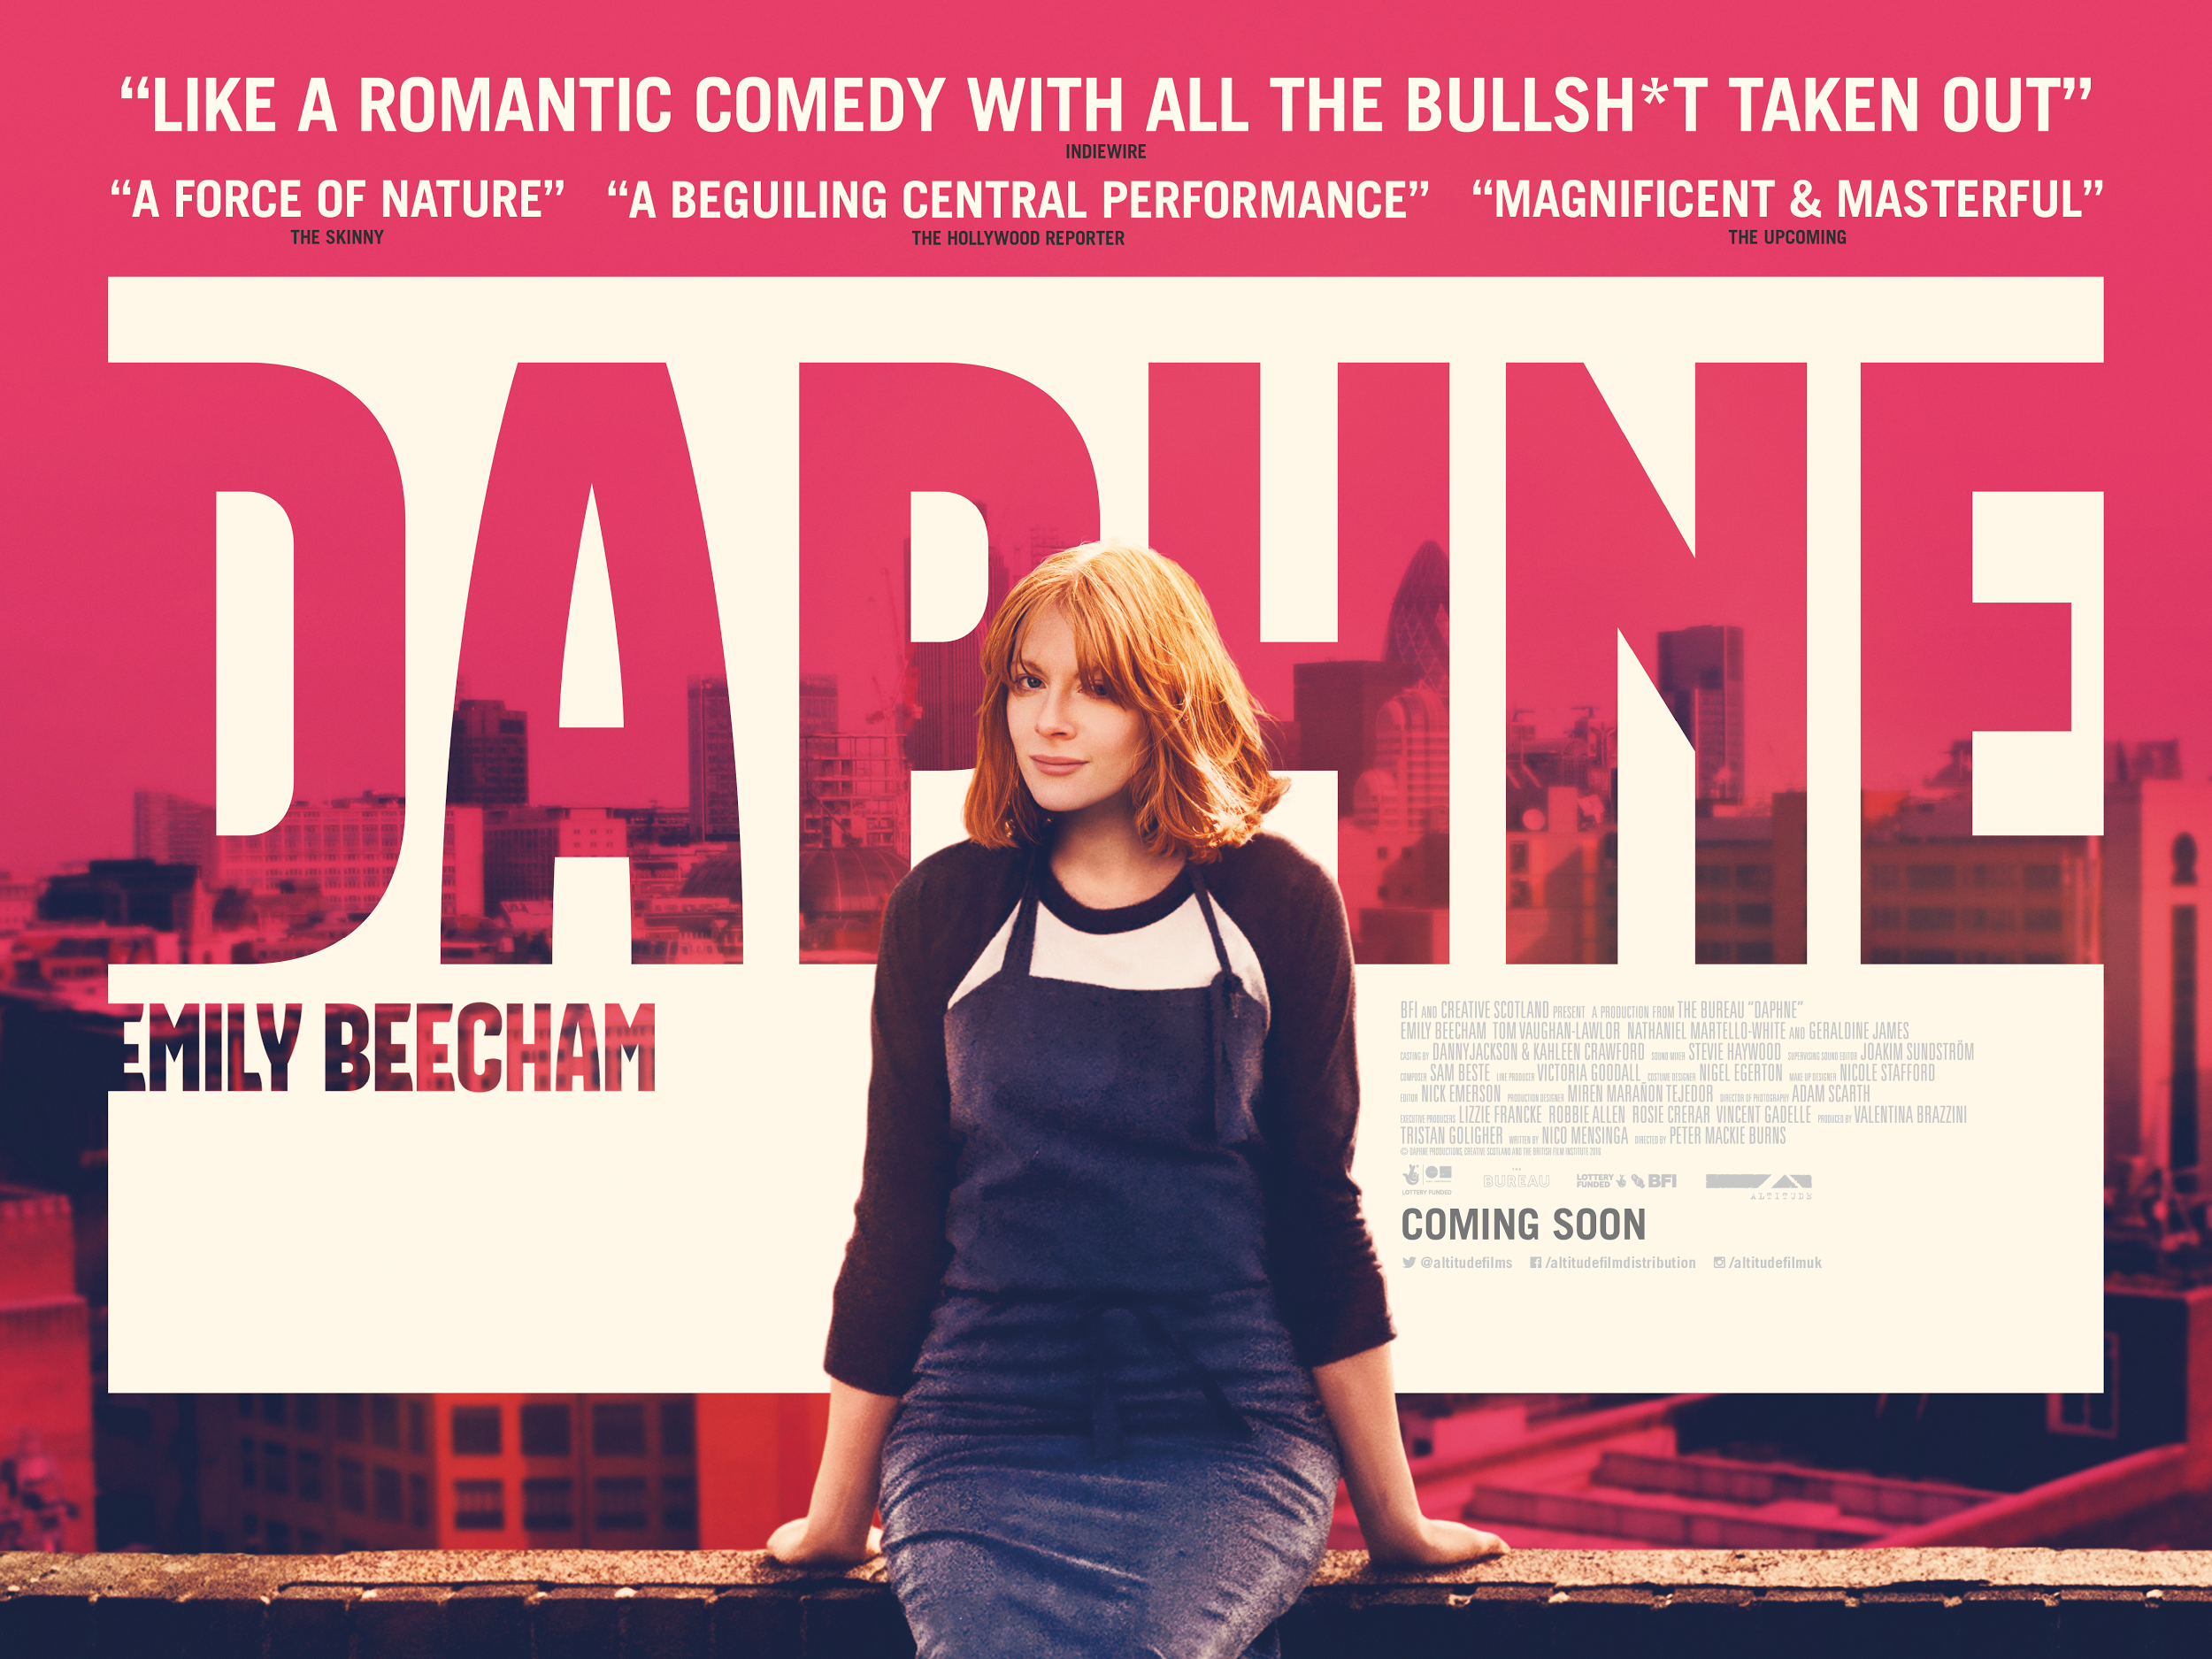
Daphne: Marketing Pack for venues,
part of the BFI FAN New Release Strategy

Specification details:
Daphne / UK / 2017
Dir Peter Mackie Burns
88 mins / BBFC Cert. 15
Cast includes : Emily Beecham, Geraldine James, Tom Vaughan-Lawlor, Nathaniel Martello-White, Osy Ikhile

Distributor: Altitude Films
Available: 29 September (theatrical); 13 October (non-theatrical, one-offs etc)
Booking: DelphineLievens@altitudefilment.com

Awarded:
Best Performance in a British Feature Film, Edinburgh International Film Festival
Best Screenplay Award, Valetta International Film Festival

Official Facebook: /altitudefilmdistribution
Official Twitter: @Altitudefilms / #DaphneFilm
Talent twitter socials: Peter (@LightsTheLights), Emily Beecham (@Emily_Beecham), Producer Tristan Golligher (@Tristangoligher)
Official hashtag: #DaphneFilm
Official Instagram: altitudefilmuk

Listings site: daphne.film
Distributor site: www.altitudefilment.com/film/distribution/66/daphne

Trailer YouTube link: https://www.youtube.com/watch?v=8RKOToCMuQk
Trailer Download:
https://drive.google.com/open?id=0BxwKrwy2UsAyQlRORmk0aHoxeVU

Stills/images (hi and low res): HERE
Poster - HERE
Social Media Assets - will be regularly added to this folder HERE

Download press pack including interview with Director Peter Mackie Burns and Writer Nico Mensinga, excerpts of which can be used on cinema websites, sent to press etc.

Watch this space…

We are working with Altitude to develop some top-notch online and offline assets that will help you promote Daphne. These will be accessible here. Stay tuned for:
- Clips, quote cards, GIFs and more
- Twisted inspirational quotes. Daphne is witty and smart. We’ll be using some of her cracking one-liners in assets that will get audiences both laughing and talking
- Guerilla marketing ideas
- Social media competitions
- Interviews with Director, Peter Mackie Burns, that can be used on your website and social media channels

Marketing Ideas and Daphne events
Interested in hosting an experience or a special event around Daphne? This year’s focus of the New Release Strategy is developing audiences aged 16-30 - getting them watching more great films in the cinema. Click here for some campaign and event ideas and tips to get you started, and contact your local Film Hub to enquire about regional support for a special event.

E-mail template to promote event screenings

Networks
Daphne is a great example of a British first feature and will appeal to students at local film schools, colleges and universities? Get in touch with classes in your area using this email template.

Press
Get in touch with local press for any special events with the below press release template alongside stills from the film.

Generic press template for local press and listings

Before issuing your press release, please send for approval to: kenjilloyd@altitudefilment.com
mark@mbjfilm.com

Key Press Quotes

“A distinctive, mature piece of work” - ScreenDaily

“Emily Beecham slays in a misanthropic British winner that feels like a big screen Fleabag… Like a romantic comedy with all the bulls**t taken out” – IndieWire

“A beguiling central performance” – The Hollywood Reporter

“A force of nature” ★★★★ - The Skinny

“A film of compassion and soul, with a protagonist at its heart who’s sometimes hard to like but easy to adore” ★★★★ - The Skinny

“If you love Frances Ha… then try this” – Marie Claire

“A sublime performance by Emily Beecham” – Movie Review World

“Magnificent and masterful” – The Upcoming

“Mackie Burns handles the story like a seasoned pro, and Beecham is terrifically watchable” - The Herald, Scotland

“So many movies every year blatantly manipulate audiences to try and produce such a response or emotional connection. “Daphne” achieves it by focusing on character and making its title one as believable as possible.” - RogerEbert.com

Random Acts Shorts

Screen South and the Ignition Network are proud to present two First Acts short films in partnership with Altitude and the BFI FAN New Release Strategy. These are available to be screened free of charge before Daphne. The films were commissioned by Screen South as part of the Ignition Random Acts program, which is funded by Arts Council England in collaboration with CH4 Random Acts. First Acts supports artists and filmmakers aged 16 – 24 to make 3 minute films that are bold expressions of creativity.

Walk of Shame Maisie Buck: https://vimeo.com/187026385
The Mask Sharif Persaud - https://vimeo.com/210419607

Bookings can be made through Fiona Hegarty at Fiona.Hegarty@tynesidecinema.co.uk who is looking after all the DCP distribution for the films.

Official synopsis
Daphne is a young woman negotiating the tricky business of modern life. Caught in the daily rush of her restaurant job and a nightlife kaleidoscope of new faces, she is witty, funny, the life of the party. Too busy to realise that deep down she is not happy. When she saves the life of a shopkeeper stabbed in a failed robbery, the impenetrable armour she wears to protect herself begins to crack, and Daphne is forced to confront the inevitability of a much-needed change in her life.

30 words
Daphne is a vibrant character caught in the daily rush of her restaurant job, a nightlife kaleidoscope of new faces and too busy to realise that deep down she is not happy.

50 words
Sharp witted, capable and charismatic, Daphne is a thirty-one-year-old woman negotiating the tricky business of modern life. Caught in the daily rush of her restaurant job and a nightlife kaleidoscope of new faces, Daphne seems to have everything going for her until she is forced to confront the inevitability of a much needed change.

80 words
A celebration of individuality in a mixed up world of city dwellers, Daphne is a relatable character caught in the daily rush of modern life in a metropolitan city. When she saves the life of a shopkeeper in a failed robbery, the impenetrable armour she wears to protect herself begins to crack and Daphne is forced to confront the inevitability of a much-needed change in her life.

100 words
A celebration of individuality that is free from preconceptions about class, race and gender, Daphne is a vibrant character caught in the daily rush of her restaurant job and a nightlife kaleidoscope of new faces. A thirty-one year old woman negotiating the tricky business of modern life, Daphne seems to have everything going for herself, until she saves the life of shopkeeper after a botched robbery and her once impenetrable armour she wears to protect herself begins to crack and she is forced to confront the inevitability of a much-needed change in her life.

Sample Tweets

Attach stills/trailer where possible and remember to use @AltitudeFilms and/or #daphnefilm

‘Emily Beecham Slays’ in @lightthelights first feature film #daphnefilm. Check out the trailer here: (link to review) + upload video of trailer

Don’t miss @lightthelights’s #daphnefilm when it hits UK cinema screens from 29th September (+ Trailer + ticket link)

Sharp-witted and charismatic, don’t forget to book your tickets to #Daphnefilm

Long Days. Late Nights. Stuck in a rut… Meet Daphne. + Trailer/assets

“Magnificent and masterful” – @The_Upcoming | “If you love Frances Ha… then try this” – @MarieClaire + Trailer

Sample Facebook Posts:

Attach stills/trailer where possible and remember to use #daphnefilm

A striking debut drama from Bafta award nominee Peter Mackie Burns, don’t miss the UK Premier of Daphne on September 29th! Get your tickets here: (trailer + ticket link)

“This is a film that respects how difficult it can be for people to recognize the moments that change them, or understand why those are the moments that do and so it takes a while for Daphne to recognize how shaken she was” @IndieWire + trailer

One of the top feature films to watch from the @BFI this year, don’t miss out on Daphne, launching on 29th September at xxx time, be there!

Social Copy
If you would like to quote Daphne’s views on life, then we have selected some of the best quotes for use below.

Daphne Quotes
- “I’m very adept at ignoring important questions”
- “Love... It’s a sickness! And that’s the thing that we all want. It’s f*cked!”
- “I don’t want you to expect one thing about me, and then get mad when I’m not that.”
- “Don’t try and psychoanalyse me!”
- “My life’s terrible. I haven’t shaved my legs in months. I’m wearing a sports bra coz I couldn’t be arsed. I’ve basically given up on life.”
- “so much of what’s called love is really… Just people projecting their own expectations of what a love object should look like onto someone else and then getting upset when the other person fails to live up to those expectations”
- “I’m at the thirty year stage of my life and I find myself lost in a deep dark wood.”
- “Healthy cynicism and neurotic cynicism are, like, different”
- “Internet dating is consumerism masquerading as love”
- “You sir, are a fabulous c*nt”

Conversations About Cinema

Conversations About Cinema postcards that invite audiences to share their comments are available free of charge. Contact alice.q@watershed.co.uk to request for a bundle to be sent to your venue. All you need is a cork board to display the comments!
