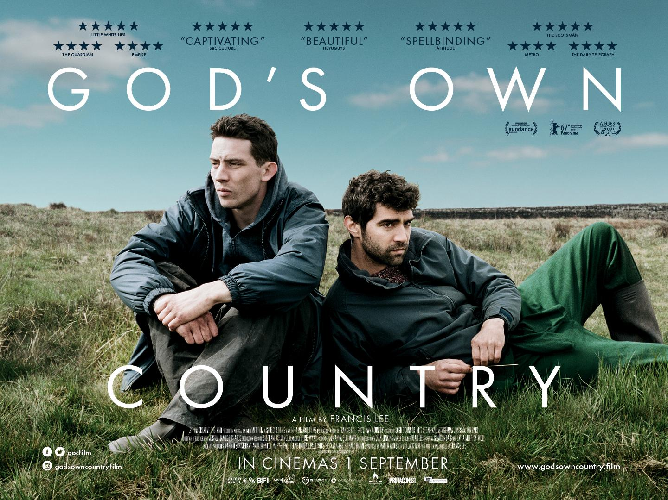

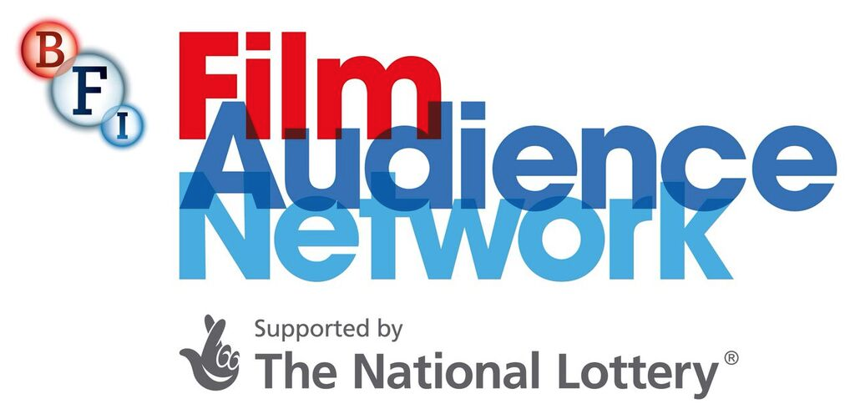

God’s Own Country: Marketing Pack for venues,
part of the BFI FAN New Release Strategy

Specification details:
God’s Own Country / UK / 2017
Dir Francis Lee
104 mins approx. / BBFC Cert. 15
Cast includes : Josh O’Connor, Alec Secareanu, Ian Hart & Gemma Jones
In cinemas from 1 Sept
(Preview screenings with Q&As from 21 Aug)
Distributor: Picturehouse Entertainment
Booking: nick.m@picturehouses.co.uk

Awarded:
Michael Powell Award for Best British Feature Film, Edinburgh International Film Festival
Manner Jury Award for Best Film,
Berlin International Film Festival
Directing Award for World Cinema - Dramatic, Sundance Film Festival

Official Facebook: https://www.facebook.com/gocfilm/
Official Twitter: @gocfilm
Official Instagram: godsowncountryfilm
Official hashtag: #godsowncountryfilm
Listings site: www.godsowncountry.film
Distributor site: https://www.picturehouseentertainment.co.uk/films/gods-own-country/

Trailer:
YouTube link: https://www.youtube.com/watch?v=2sPE9sbXQoQ
Trailer Download: http://bit.ly/2uV1C4
Stills/images (hi and low res) : info@picturehouseentertainment.co.uk

Film quads and trailer will be sent to your venue upon booking. Layered artwork and other materials are available on request from : info@picturehouseentertainment.co.uk

DIY God’s Own Country events
Interested in hosting a special event around God’s Own Country? This year’s focus of the New Release Strategy is developing audiences aged 16-30 - getting them watching more great films in the cinema. Click here for some event ideas and tips to get you started, and contact your local Film Hub to enquire about regional support for a special event.

Should you be considering an event, please contact the following people at Picturehouse Entertainment before you progress with any activity:
Toby King toby.k@picturehouses.co.uk
Martin Hearn martin.h@picturehouses.co.uk
They can help provide both support and materials in relation to the film itself, as well as supplying the approvals required for any activity

Networks
Get in touch with local LGBTQ+ groups, student filmmakers (God’s Own Country is an inspirational first feature made outside of London) or other networks (young farmers?) to spread the word about your screening.

Have a look here for some ideas of networks you could contact and contact your regional Film Hub to see if there are other local networks they can put you in touch with.

A follow up or preliminary phonecall is a good idea. It’s obvious really, but a real person explaining why this film might interest their group makes a difference.

E-mail template Young Person/LGBT+ networks.
E-mail template for Event screenings.

As mentioned above, should you be considering an event please contact toby.k@picturehouses.co.uk and martin.h@picturehouses.co.uk at Picturehouse Entertainment before you proceed with any activity. They can advise and provide any approvals as required.

Press
Get in touch with local press for any special events with the below press release template alongside stills from the film.
NB. Please ensure that you get any events approved before you put details on public display, go on sale or alert press about them.

Generic press template for local press and listings

And before sending out your own press release, please send to the following contacts for review/approval :
John.Scrafton@ddapr.com
toby.k@picturehouses.co.uk

Key Press Quotes

“One of the most assured British debuts of recent years” Sight & Sound

“Sensual, surprising and incredibly affecting” ★★★★★ Little White Lies

“A beautiful romantic story full of hope” - ★★★★★ HeyUGuys

“Captivating” - ★★★★★ BBC Culture

“Spellbinding” - ★★★★★ Attitude

“Wonderful” - ★★★★ The Times

“Unmissable” - ★★★★ Metro

★★★★★ The Scotsman

★★★★ The Guardian

★★★★ Empire

★★★★ The Daily Telegraph

Official synopsis
Captivating and broodingly beautiful, God's Own Country is the award winning debut feature from writer/director Francis Lee. Bracingly open hearted, this is a thrillingly romantic story set in the heart of rural Yorkshire. Both poignant and moving, this finely crafted British film features a host of standout performances, marking it out as an absolute must see.

Johnny Saxby (Josh O’Connor) works long hours on his family’s remote farm in the north of England. He numbs the daily frustration of his lonely existence with nightly binge-drinking at the local pub and casual sex. But when a handsome Romanian migrant worker (Alec Secareanu) arrives to take up temporary work on the family farm, Johnny suddenly finds himself having to deal with emotions he has never felt before. As they begin working closely together during lambing season, an intense relationship starts to form which could change Johnny’s life forever.

30 words
Johnny is desperate to escape the daily grind of life on the farm where he lives. But with the arrival of Romanian farmhand, Gheorghe, Johnny slowly finds hope, love and tenderness.

50 words
Trapped by the loneliness of daily life on his family’s farm, Johnny (Josh O’Connor) indulges in binge-drinking and casual sex to alleviate the pain. But when handsome Romanian farmhand (Alec Secareanu) arrives, Johnny’s world is turned upside down. A stunning ode to love and life, filled with hope for a better future.

100 words
Trapped by the loneliness of daily life on his family’s remote farm in the north of England, Johnny (Josh O’Connor) indulges in binge-drinking and casual sex to numb his daily frustration. But when a handsome Romanian farmhand (Alec Secareanu) arrives, Johnny finds himself dealing with emotions he has never felt before. Set against a stunning Yorkshire backdrop, God’s Own Country is the award-winning debut feature film from British writer/director Francis Lee. A stunning ode to love and life, filled with hope for a better future, God’s Own Country is set to be one of the most celebrated films of the year.

150 words
Johnny Saxby (Josh O’Connor) works long hours on his family’s remote farm in the north of England, numbing his daily frustration with nightly binge drinking at the local pub and casual sex. But when a handsome Romanian migrant worker (Alec Secareanu) arrives to take up temporary work, Johnny slowly discovers there is much more to life than he had ever imagined, including hope, love and tenderness.

Set against a stunning Yorkshire backdrop, God’s Own Country is the award-winning debut feature film from British writer/director Francis Lee. Poignant, romantic and unforgettable, the film features standout performances from an impressive cast.

Touching on issues of contemporary rural life and a young generation’s aspirations for building a better future, Lee reveals the strength and intimacy that can flourish in even the most seemingly isolated and hardened of human spirits. Critically lauded and presented at films festivals worldwide, this is guaranteed to be one of the most celebrated and significant films of the year.

Sample Tweets

Attach stills/trailer where possible and remember to use @gocfilm and/or #godsowncountryfilm

Don’t miss this year’s most anticipated British film #godsowncountryfilm hits UK cinema screens from Sept 1st. TRAILER
Don’t miss “One of the most assured British debuts of recent years” @SightSoundmag #godsowncountryfilm hits UK cinema screens from Sept 1st. TRAILER
“Sensual, surprising and incredibly affecting” ★★★★★ Little White Lies #godsowncountryfilm hits UK cinema screens from Sept 1

Poignant and moving #godsowncountryfilm is a must-see @VENUE this DAYOFWEEK TICKETLINK.

#godsowncountryfilm is the remarkable, award winning debut feature film from British writer/director Francis Lee @strawhousefilms see it @VENUE TICKETLINK.

#godsowncountryfilm is a contemporary classic that will wrap you up in its soft, warm embrace. See it on the big screen @VENUE and fall in love TICKETLINK.

Sample Facebook Posts:

Attach stills/trailer where possible and remember to use #godsowncountryfilm

God’s Own Country is “A beautiful romantic story full of hope” - ★★★★★ HeyUGuys. Let this year’s most anticipated British film take you on a heartfelt journey of hope and love. #godsowncountryfilm TICKET LINK

It’s “Sensual, surprising and incredibly affecting” ★★★★★ Little White Lies. Don’t miss #godsowncountryfilm, showing DATE TRAILER TICKET LINK
God’s Own Country is “Captivating” - ★★★★★ BBC Culture and “Spellbinding” - ★★★★★ Attitude. #godsowncountryfilm TICKET LINK

Set against the stunning backdrop of rural Yorkshire, God’s Own Country is a stand out debut feature film. Touching on issues of contemporary rural life and a young generation’s hope for a better future, writer/director Francis Lee reveals the strength and tenderness that can be found in even the most isolated and hardened of human spirits. Don’t miss #godsowncountryfilm now showing TICKET LINK

Conversations About Cinema

Conversations About Cinema postcards that invite audiences to share their comments are available free of charge. Contact alice.q@watershed.co.uk to request for a bundle to be sent to your venue. All you need is a cork board to display the comments!
